**Probability Distributions**

## **Normal distribution**

A [normal distribution](https://www.statisticshowto.com/probability-and-statistics/normal-distributions/), sometimes called the bell curve, is a distribution that occurs naturally in many situations. For example, the bell curve is seen in tests like the SAT and GRE. The bulk of students will score the [average](https://calculushowto.com/average-value-of-a-function/#def)(C), while smaller numbers of students will score a B or D. An even smaller percentage of students score an F or an A. This creates a distribution that resembles a bell (hence the nickname). The bell curve is symmetrical. Half of the data will fall to the left of the [mean](https://www.statisticshowto.com/probability-and-statistics/statistics-definitions/mean-median-mode/#mean); half will fall to the right.  
Many groups follow this type of pattern. That’s why it’s widely used in business, statistics and in government bodies like the [FDA](https://www.fda.gov/default.htm):

* Heights of people.
* Measurement errors.
* Blood pressure.
* Points on a test.
* IQ scores.
* Salaries.

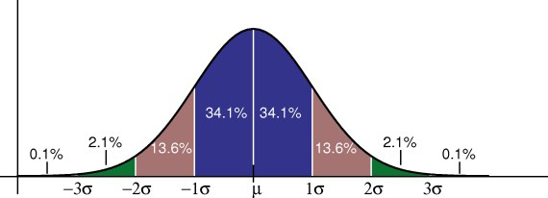

## **Properties of a normal distribution**

* The [mean, mode and median](https://www.statisticshowto.com/probability-and-statistics/statistics-definitions/mean-median-mode/) are all equal.
* The curve is symmetric at the center (i.e. around the mean, μ).
* Exactly half of the values are to the left of center and exactly half the values are to the right.
* The total area under the curve is 1.

## **Distribution of Data**

One way of figuring out how data are distributed is to plot them in a graph. If the data is evenly distributed, you may come up with a **bell curve**. A bell curve has a small percentage of the points on both tails and the bigger percentage on the inner part of the curve. In the **standard normal model**, about 5 percent of your data would fall into the “tails” (colored darker orange in the image below) and 90 percent will be in between. For example, for test scores of students, the normal distribution would show 2.5 percent of students getting very low scores and 2.5 percent getting very high scores. The rest will be in the middle; not too high or too low. The shape of the standard normal distribution looks like this:

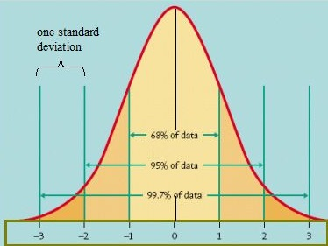

### **Practical Applications of the Standard Normal Model**

The standard normal distribution could help you figure out which subject you are getting good grades in and which subjects you have to exert more effort into due to low scoring percentages. Once you get a score in one subject that is higher than your score in another subject, you might think that you are better in the subject where you got the higher score. This is not always true.

You can only say that you are better in a particular subject if you get a score with a certain number of standard deviations above the mean. The standard deviation tells you how tightly your data is clustered around the mean; It allows you to compare different distributions that have different types of data — including different means.

For example, if you get a score of 90 in Math and 95 in English, you might think that you are better in English than in Math. However, in Math, your score is 2 standard deviations above the mean. In English, it’s only one standard deviation above the mean. It tells you that in Math, your score is far higher than most of the students (your score falls into the tail).  
Based on this data, you actually performed better in Math than in English!

## **Binomial Distribution**

A **binomial distribution** can be thought of as simply the probability of a SUCCESS or FAILURE outcome in an experiment or survey that is repeated multiple times. The binomial is a type of distribution that has **two possible outcomes** (the prefix “[bi](http://membean.com/wrotds/bi-twice)” means two, or twice). For example, a coin toss has only two possible outcomes: heads or tails and taking a test could have two possible outcomes: pass or fail.

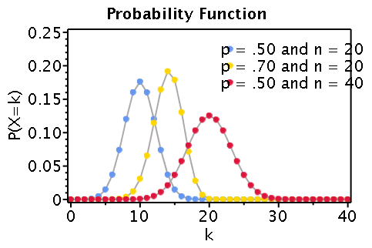

For example, let’s suppose you wanted to know the probability of getting a 1 on a die roll. if you were to roll a die 20 times, the probability of rolling a one on any throw is 1/6. Roll twenty times and you have a binomial distribution of (n=20, p=1/6). SUCCESS would be “roll a one” and FAILURE would be “roll anything else.” If the outcome in question was the probability of the die landing on an even number, the binomial distribution would then become (n=20, p=1/2). That’s because your probability of throwing an even number is one half

## **Criteria**

Binomial distributions must also meet the following three criteria:

1. **The number of observations or trials is fixed.** In other words, you can only figure out the [probability](https://www.statisticshowto.com/probability-and-statistics/probability-main-index/) of something happening if you do it a certain number of times. This is common sense—if you toss a coin once, your probability of getting a tails is 50%. If you toss a coin a 20 times, your probability of getting a tails is very, very close to 100%.
2. **Each observation or trial is** [independent](https://www.statisticshowto.com/probability-and-statistics/dependent-events-independent/#or). In other words, none of your trials have an effect on the probability of the next trial.
3. The **probability of success** (tails, heads, fail or pass) is **exactly the same** from one trial to another.

## **What is a Binomial Distribution? Real Life Examples**

Many instances of binomial distributions can be found in real life. For example, if a new drug is introduced to cure a disease, it either cures the disease (it’s successful) or it doesn’t cure the disease (it’s a failure). If you purchase a lottery ticket, you’re either going to win money, or you aren’t. Basically, anything you can think of that can only be a success or a failure can be represented by a binomial distribution.

## **Poisson Distribution**

A Poisson distribution is a tool that helps to predict the probability of certain events from happening when you know how often the event has occurred. It gives us the [**probability**](https://www.statisticshowto.com/probability-and-statistics/probability-main-index/)**of a given number of events happening in a fixed interval of time**.

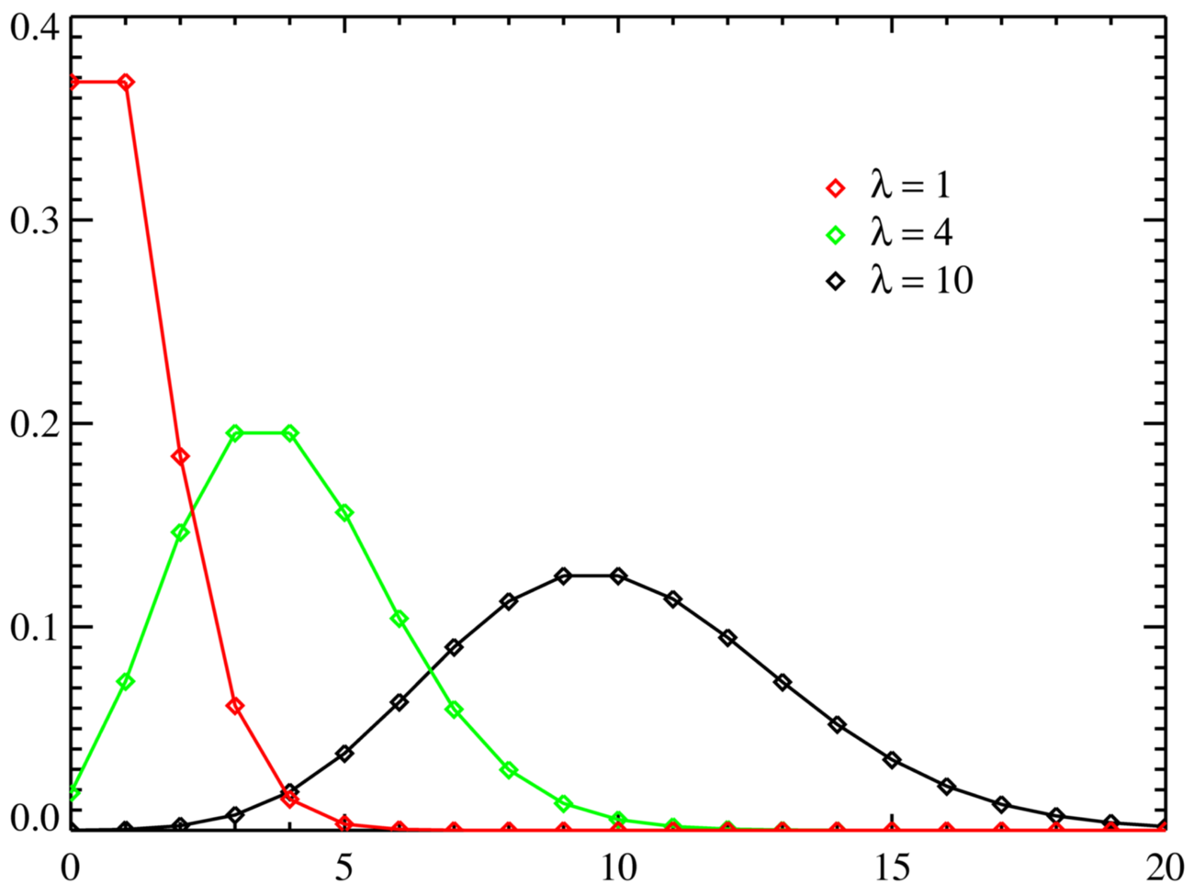

*Poisson distributions, valid only for*[*integers*](https://www.statisticshowto.com/integer/)*on the horizontal axis. λ (also written as μ) is the expected number of event occurrences.*

A textbook store rents an average of 200 books every Saturday night. Using this data, you can **predict the probability that more books will sell** (perhaps 300 or 400) on the following Saturday nights. Another example is the number of diners in a certain restaurant every day. If the [average](https://www.statisticshowto.com/arithmetic-mean/)number of diners for seven days is 500, you can predict the probability of a certain day having more customers.

Because of this application, Poisson distributions are used by businessmen to make **forecasts** about the number of customers or sales on certain days or seasons of the year. In business, overstocking will sometimes mean losses if the goods are not sold. Likewise, having too few stocks would still mean a lost business opportunity because you were not able to maximize your sales due to a shortage of stock. By using this tool, businessmen are able to estimate the time when demand is unusually higher, so they can purchase more stock. Hotels and restaurants could prepare for an influx of customers, they could hire extra temporary workers in advance, purchase more supplies, or make contingency plans just in case they cannot accommodate their guests coming to the area.  
With the Poisson distribution, companies can adjust supply to demand in order to keep their business earning good profit. In addition, waste of resources is prevented.

## **Bernoulli Distribution**

A Bernoulli distribution is a [discrete probability distribution](https://www.statisticshowto.com/discrete-probability-distribution/) for a [Bernoulli trial](https://www.statisticshowto.com/bernoulli-distribution/#trial) — a random experiment that has only two outcomes (usually called a “Success” or a “Failure”). For example, the probability of getting a heads (a “success”) while flipping a coin is 0.5. The probability of “failure” is 1 – P (1 minus the probability of success, which also equals 0.5 for a coin toss). It is a special case of the [binomial distribution](https://www.statisticshowto.com/probability-and-statistics/binomial-theorem/binomial-distribution-formula/) for n = 1. In other words, it is a binomial distribution with a single trial (e.g. a single coin toss).

The probability of a failure is labeled on the x-axis as 0 and success is labeled as 1. In the following Bernoulli distribution, the probability of success (1) is 0.4, and the probability of failure (0) is 0.6:

